Getting Your Working With Children Check – WA

Applying for your volunteer Working with Children Check is easy to do. Simply collect a form from your local Australian Post Office. For tips on filling out your form, you can visit www.workingwithchildren.wa.gov.au/applicants-card-holders/applying-for-a-wwc-check/how-to-apply.

You will need to submit your details, prove your identity, and list our details:

WA Institute of Surveyors
+61 424 177 510
admin@surveyorswa.org.au
PO Box 1121, Bentley DC, Western Australia 6983
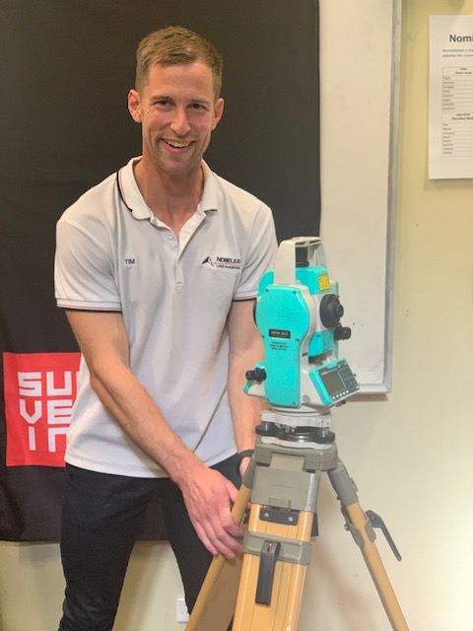
You will also have to specify the work that you are completing, we suggest you check the child-related sector ‘Category 4’.

You will also need to have brought along documents to prove your identity. They should include:
- Your date of birth
- Proof of your current address
- Photographic identification

In total you will need 100 points of identification.
When you submit your application, there is also a small cost of just $11 in Western Australia. Ideally, you will need to allow four weeks to receive your check, so the sooner you can apply, the better.

As ever, the WA Institute of Surveyors sincerely thanks the amazing, supportive industry ambassadors who are so committed to promoting the surveying brand, and alerting tomorrow’s surveyors to everything the profession offers, today.

