Getting Your Working With Children Check – Vic

Applying for your volunteer Working with Children Check is easy to do and completely free. You can submit for a check online in just five minutes at www.workingwithchildren.vic.gov.au. There, you will need to submit your details, prove your identity, and if you wish, list our organisational details:

Surveying Task Force Inc.
(03) 9326 8173
trysurveying@alifewithoutlimits.com.au
Suite 509, 370 St Kilda Road, Melbourne, VIC 3004
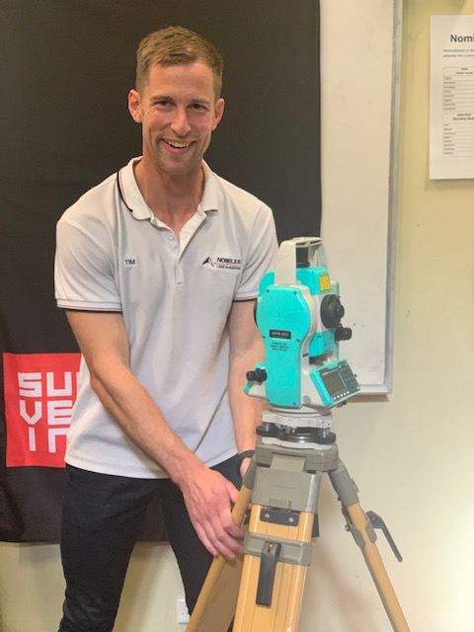
You may also have to specify that you plan to use the check at educational institutions; thus, if you a prompted for an organisational code, use 44 and 46.
Once submitted, you will be asked to follow this up with a quick visit to an Australian Post outlet to finalise your application. Ideally, allow four weeks to receive your check, so the sooner you can apply the better.

As ever, the Surveying Task Force sincerely thanks the amazing, supportive industry ambassadors who are so committed to promoting the surveying brand, and alerting tomorrow’s surveyors to everything the profession offers, today.

