Getting Your Working With Children Check – NSW

Applying for your volunteer Working with Children Check is easy to do and completely free. You can submit for a check online in just five minutes at www.service.nsw.gov.au/transaction/apply-working-children-check. There, you will need to submit your details, prove your identity, and list our details:

NSW Surveying Taskforce
(02) 9294 4475
trysurveying@alifewithoutlimits.com.au
Suite 702, 350 Kent Street, Sydney, NSW 2000

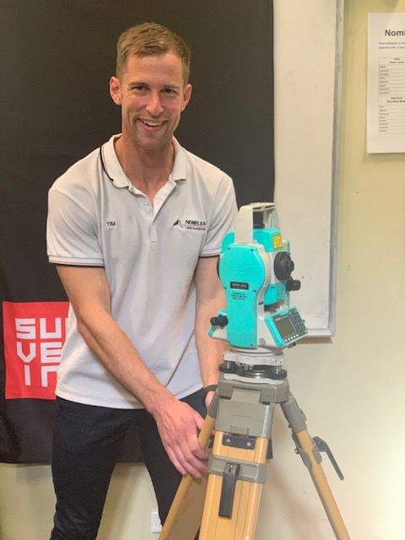
You will also have to specify that you need to use the check in the child-related sector ‘education’.

Once submitted, you will be asked to follow this up with a quick visit to an Australian Post outlet to finalise your application. Ideally, you will need to allow four weeks to receive your check, so the sooner you can apply the better.

As ever, the NSW Surveying Taskforce sincerely thanks the amazing, supportive industry ambassadors who are so committed to promoting the surveying brand, and alerting tomorrow’s surveyors to everything the profession offers, today.

